

A Project Report On

**ATM User**

**By**

**Shruthi.B**

**Batch:** 2021 – 6526

**Center: Thane**

Under the Guidance of,

**Chittaranjan Ghosh.**

**Technical Trainer**

**EduBridge**

(School of coding)

## Introduction:

ATM user project is used to transaction of the account , update the account , Withdraw the amount, Open account, close account, Check balance which makes user easy to about their own Bank Details by any place..

. **Modules:-**

* Atm user Modules
* Atm Help Moduel
* Access Moduel

I have developed this Application in **Java, JSP, Servlets, Hibernate and MySQL.** It’s a web-based projects so I have used **HTML, CSS, JavaScript and Bootstrap ,Thymleaf**.

The main objective of the ATM Project is to reduce manual work and time. It is difficult and time-consuming to collect all the details from each User. To avoid this problem, we have planned to develop a web-based ATM Project. In Access Module, admin can add the Category and Products in the specific category. He can also view the total number of users at present in the website. And category and product details also. Admin can only see the admin page and cart if he wants to order something.

* It manages the details of User records, Withdraw and Deposit Amount in different place happening.
* Saves the time of Bank officer and User.
* This system makes User more secure.

Access Module: Employee can able to handle Access module. It provides access to the User for updating account , close account, check Bank Details with a username and password.

ATM User: User can access this website by Logging IN .

Can be able to withdraw and Deposit the amount.

ATM Help: User can update the process with closing account, changing Password, opening new account, checking the Details.

**Software Requirements:**

**Front end:** Java/J2EE technologies (Servlet, JSP), HTML, CSS, JavaScript, Bootstrap, Thymleaf, Hibernate.

**Back end**: MySQL workbench 8.0 CE.

**Middleware/Server:** Apache Tomcat v8.5. IDE: Spring tool suite for Java EE Developers

**Browser:** Best result on Google Chrome

**Operating System:** Window

SQL Database Queries

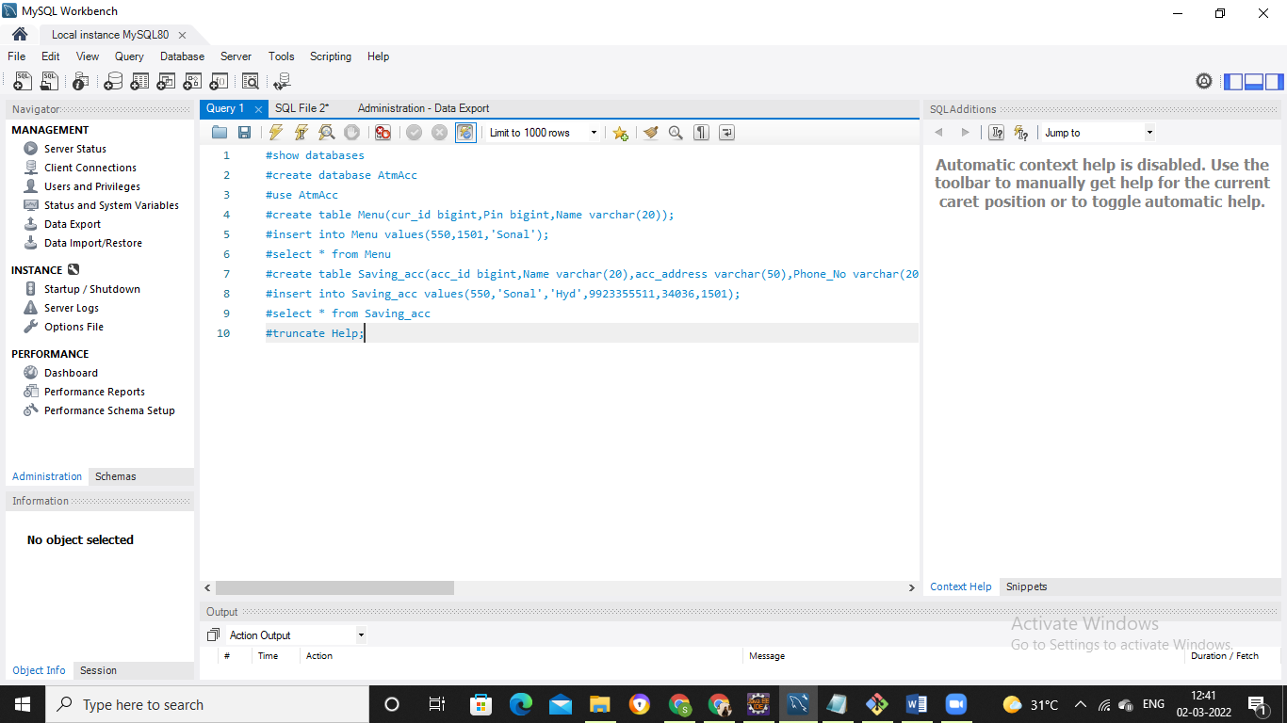

**SQL Output:**

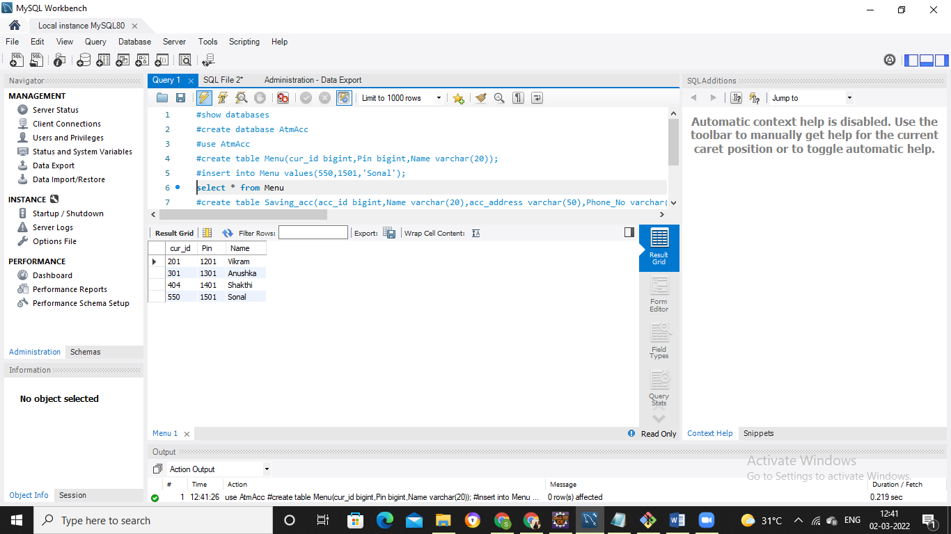

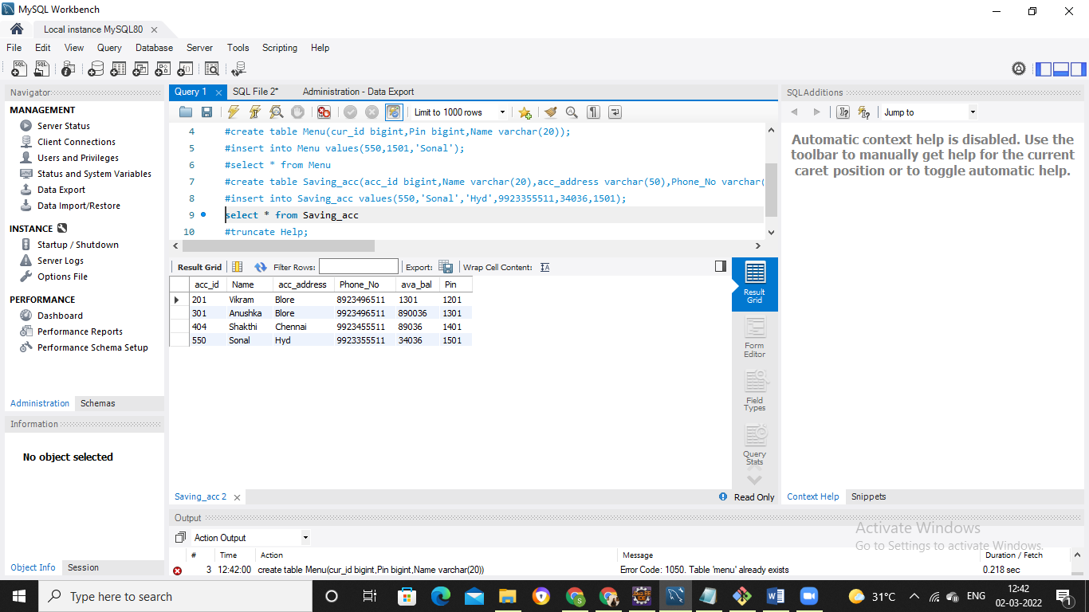

**Menu/Help Module Output:**

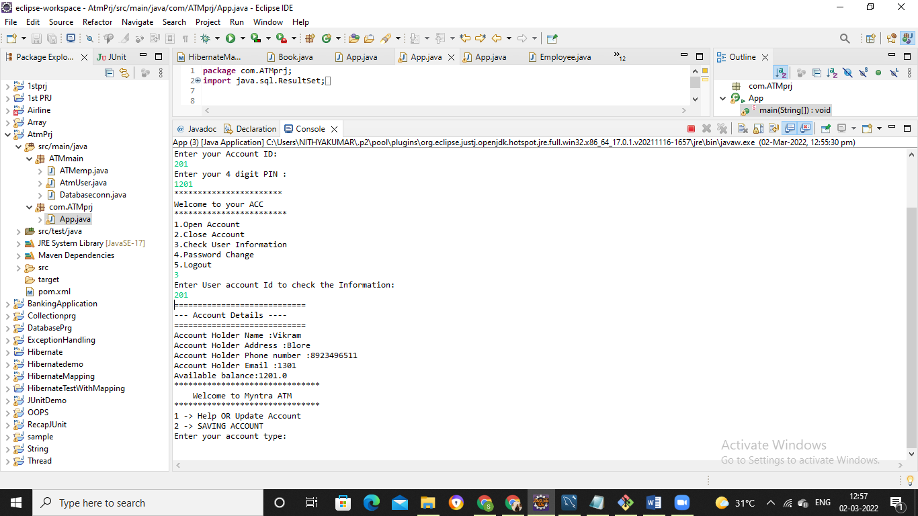

**User // Saving Account Output:**

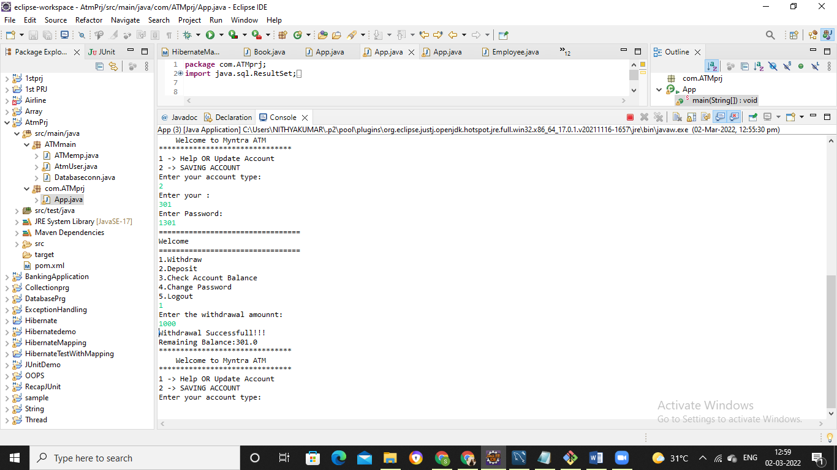

**Thank you…..**

**Suggestions?......**